**BSIS Program Review Part II**

Jacqueline Rios

Library and Information Science, University of South Florida

LIS 4934: BSIS Senior Capstone

Dr. Alicia K. Long

March 31, 2024

**Introduction**

I have high regard for my project-based courses that guided me with frameworks and practices to apply the culmination of my skills to my future career in web development. They also revealed and instilled my passion and fondness for my aspiring career as a front-end developer. These courses were LIS3361 Page Design and Management with instructor Dr. John J. Sullivan, and LIS 3783 Information Architecture with instructor Dr. Vanessa Reyes. The assignments that were important to me were the Final Project, the finalized version of a resume website for Page Design and Management, and assignments in user personas and user scenarios for Information Architecture.

**User Personas & User Scenarios:**

These assignments have significantly enhanced my ability to create efficient user-centered designs. They introduced me to crucial research and practices for ensuring a conscientious design providing users with the tools and content they need to achieve their goals. It is critical to devote time to research methodologies such as interviews or usability testing to understand user needs and behaviors accurately.

For instance, in creating user personas for my project website focused on a Juice Bar and Supplements restaurant in underserved Hispanic communities, I developed a range of unique persona bios to represent a diverse set of likely users. Each in-depth persona considered social contexts, technological experiences, environments, and specific goals and tasks, guiding me to create a comprehensive design to support their needs. User Scenarios allowed me to identify relevant information needs and ideal experiences for utilizing a client’s website. By creating an elaborate anecdote of my user personas employing my developed website, considering the setting and specific issue helped me realize the appropriate organization and navigation I need to incorporate into my website for prospective users to achieve their needs. These practices help consider the perspective of users, freeing us from the constraints of a client stakeholder or developer overlooking the abilities and needs of their users. Failing to be considerate can lead to efforts from all stakeholders invested in the project in vain, as they often will not look forward to returning and utilizing your services again.

By incorporating insights gained from research, user personas, and persona scenarios, I ensure that the website design aligns with user expectations and contributes positively to their experiences. This approach enhances usability and maximizes the investment and efforts of developers and client stakeholders, ultimately leading to successful outcomes for all parties involved.

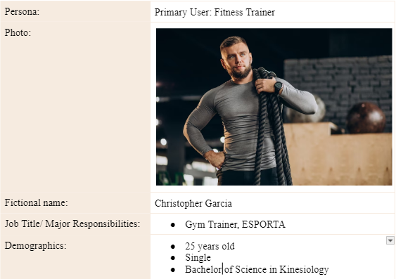

Figure 1: First Half of a “Christopher Garcia” User Persona

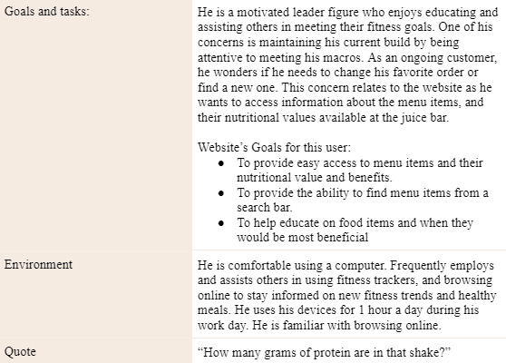

Figure 2: Second half of “Christopher Garcia” User Persona

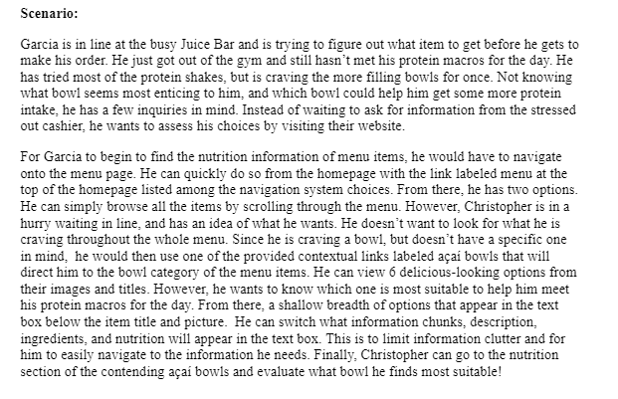

Figure 3: “Christopher Garcia” User Scenario

**Resume Website - Final Project**

The final project in this project-based course encompassed a series of assignments, culminating in my first end-to-end front-end development project. Throughout the semester I applied my lessons to tasks I will be dealing with in the future. This included programming and designing my website through HTML and Stylesheets. I began utilizing relevant software and organization practices on web editors for efficient coding and web hosting platforms to ease troubleshooting and future management for my website. I gained hands-on experience in troubleshooting my website and ensuring its functionality.

The progression from smaller assignments to the final project was immensely fulfilling. It provided great guidance yet motivated creativity, boosting the confidence to take on responsibilities pertinent to my aspiring career as a web developer. My eagerness and passion to work on this big project reinforced my commitment to pursuing a career in web development.

**Conclusion**

These assignments helped me nurture pertinent skills and practices for creating ideal websites from start to finish. The assignments enhanced my ability to create user-centered web pages that will resonate with users. I have enjoyed and look forward to providing striking aesthetics and manageable websites for my future clients and users. These courses molded my mission in my career, striving for a user-centered design that is considerate of my clients and users, assisting their goals and tasks effectively.